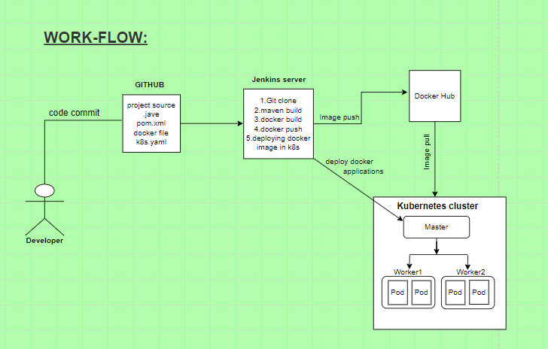

 Work Flow :

* Developer develops a code and they push developed code into GitHub Repository.
* We will integrate GitHub with Jenkins. Whenever new code commit happens into GitHub repository then Jenkins will pull that code and build with Maven.
* Once the build is done the artifact will be generated.  The generated artifact will be stored in Jfrog Artifactory.
* Then create docker image with docker file and push Docker image into dockerhub repository.
* then we will create a kubernetes cluster and deploy that application
* kubernetes cluster will have one master node and multiple worker nodes
* Jenkins will interact with master machine and finally deploy our application inside pod in kubernetes